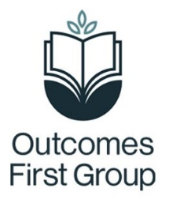
Local Area Pack – Careers Lead Information
This local area pack includes a variety of different information to support staff in school to better understand the opportunities for young people when they leave school.
The information provided includes:
- Details of the local offer websites where you can find information around what each local authority provides for young people, including those with SEND
- A list of next steps setting options to explore within your local authorities
- Links to support for parents/carers in their local authority
- Information around apprenticeships and disability confident employers
- Information around supported internships
Please use this information when supporting young people to explore their options when they are ready to transition from your school. The pack can be utilised on a 121 basis with specific students, as an exploration activity during lessons or as a homework or support tool for young people with specific career progression needs.
If a young person travels in from or is remotely based in a local authority not listed in the pack or you don't feel there are suitable options to meet a young person’s needs, then please contact your Regional Careers Advisor for further information.
The information is subject to change with annual updates as the information provided will be supported by information of the nature of the current Y11 cohort and destinations young people have previously transitioned on to.
You can access the information below in the following ways:
- If you are accessing this pack digitally then each blue, underlined piece of text is a link which will take you straight to each website.
- If you have a paper copy of this document then there is a QR code which can be scanned to open the websites on your phone or tablet (scan by opening your camera on your smart phone and hovering over the barcode, a link will appear which, if clicked, will take you straight to the website).
- Alternatively, if you are accessing a paper copy and do not have internet access, a brief description of the service has been provided – please speak to your careers lead if you require further information offline.
The careers lead must ensure the pack is sent home at the start of each academic year to all students, particularly those in year 9 and above.
It is also the role of the careers lead to ensure they work with their advisor to provide information about the needs of their students and previous destinations to allow for effective updating of the pack.

