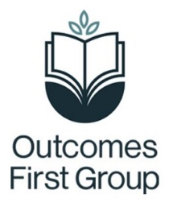
Local Area Pack – Parent / Carer information
This local area pack includes a variety of different information to support you when exploring next steps with your young person. The information provided includes:
- Details of the local offer websites where you can find information around what each local authority provides for young people, including those with SEND
- A list of next steps setting options to explore within your local authorities
- Links to support in your local authority
- Information around apprenticeships and disability confident employers
- Information around supported internships
If your young person travels in from or is remotely based in a local authority not listed in the pack, or you don't feel there are suitable options to meet your young person’s needs, then please discuss this with the Careers Lead at school. Where necessary, they will liaise with your Regional Careers Advisor for further support in providing a bespoke list for your young person or locality.
The information is subject to change with annual updates as the information provided will be supported by information of the nature of the current Y11 cohort and destinations young people from school have previously transitioned on to.

You can access the links in the Local Area Pack in the following ways:
- If you are accessing this pack digitally, then each blue, underlined piece of text is a link which, when clicked on, will take you straight to each website.
- If you have a paper copy of this document then there is a QR code which can be scanned to open the websites on your phone or tablet (scan by opening your camera on your smart phone and hovering over the barcode, a link will appear which, if clicked, will take you straight to the website).
- Alternatively, if you are accessing a paper copy and do not have internet access, a brief description of the service has been provided – please speak to your careers lead if you require further information offline.

