**, Picture**

**Careers Policy**

**Our Careers Strategy**

# Our Commitment

There has never been a time when careers guidance has been more critical for young people. At Options Higford, we have a vital role in preparing our learners for their next stage in education, training, or employment. Our students face a rapidly evolving job market, shaped by globalisation and technological change, where many will have multiple careers or enter professions that do not yet exist. We aim to equip learners with the skills and confidence to manage these transitions, supporting them in navigating choices and fulfilling aspirations.

# Whole School Approach

Our careers education is a whole-school responsibility, underpinned by a shared commitment to raising aspirations. Careers learning is embedded across the curriculum and supported by impartial advice, one-to-one guidance for KS3–5, and external partners. This inclusive model aligns with the January 2023 DfE guidance and the Gatsby Benchmarks, ensuring each student can make informed and supported decisions.

# Aims and Objectives

• Create a high-aspiration culture through embedded careers education and guidance.

• Build a robust network of employer and education provider partners.

• Track engagement and evaluate impact through destination data and student feedback.

• Tailor career development experiences to student aspirations and needs.

# Legal Framework

This policy is informed by statutory guidance and legal duties, including:

• Careers guidance statutory guidance 2023

• Education Act 1997

• Apprenticeships, Skills, Children and Learning Act 2009

• Equality Act 2010

• Children and Families Act 2014

• Provider Access Legislation (PAL) 2023

# Addressing the Needs of Students

Our careers programme is built around individual aspirations, using surveys, guidance, and EHCP reviews to shape experiences. We hold and monitor destination data for a minimum of three years, providing longitudinal support for students post-16.

# Students with SEND

Careers support for SEND learners is personalised and aspirational. Coordinated by the Careers Lead, SENDCo, and families, students engage in realistic planning, work-related learning, and tailored guidance. We ensure employer partnerships accommodate learner needs and promote disability representation in careers.

# Staff Training and Updates

Staff receive regular CPD and resources to stay informed, including:

• The Careers Policy

• CPD calendar

• Updates on local/national careers initiatives

# External Engagement Planning

We engage local employers for:

• Site visits

• In-school talks

• Work experience (on- and offsite)

• Careers events

Younger learners explore local jobs through immersive experiences. Parental involvement is encouraged at all stages.

# The Gatsby Benchmarks

We use the Gatsby Charitable Foundation’s Benchmarks to develop and improve our careers provision and to ensure we fulfil our legal duties.

This supports students’ careers education programme and details their individual careers journey and their personal targets.

1.A stable careers programme

Every school and college should have an embedded programme of career education. The careers programme should be published on the school’s website in a way that enables students, parents, teachers and employers to access and understand it. The programme should be regularly evaluated with feedback from students, parents, teachers and employers as part of the evaluation process.

2. Learning from career and labour market information

Every student, and their parents, should have access to good quality information about future study options and labour market opportunities. They will need the support of an informed adviser to make best use of available information. By the age of 14, all students should have accessed and used information about career paths and the labour market to inform their own decisions on study options. Parents should be encouraged to access and use information about labour markets and future study options to inform their support to their children.

3.Addressing the needs of each student

Students have different career guidance needs at different stages. Opportunities for advice and support need to be tailored to the needs of each student. A school’s careers programme should embed equality and a school’s careers programme should actively seek to challenge stereotypical thinking and raise aspirations. Schools should keep systematic records of the individual advice diversity considerations throughout. given to each student, and subsequent agreed decisions. All students should have access to these records to support their career development. Schools should collect and maintain accurate data for each student on their education, training or employment destinations.

4.Linking curriculum learning to careers

All teachers should link curriculum learning with careers.

5.Encounters with employers and employees

Every student should have multiple opportunities to learn from employers about work, employment and the skills that are valued in the workplace. This can be through a range of enrichment activities including visiting speakers, mentoring and enterprise schemes. Every year, from the age of 11, students should participate in at least one meaningful encounter* with an employer. *A ‘meaningful encounter’ is one in which the student has an opportunity to learn about what work is like or what it takes to be successful in the workplace.

6.Experiences of workplaces

Every student should have first-hand experiences of the workplace through work visits, work shadowing and/or work experience to help their exploration of career opportunities and expand their networks. By the age of 16, every student should have had at least one experience of a workplace, additional to any part-time jobs they may have. By the age of 18, every student should have had one further such experience, additional to any part-time jobs they may have.

7.Encounters with further and higher education

All students should understand the full range of learning opportunities that are available to them. This includes both academic and vocational routes and learning in schools, colleges, universities and in the workplace. By the age of 16, every student should have had a meaningful encounter* with providers of the full range of learning opportunities, including Sixth Forms, colleges, universities and apprenticeship providers. This should include the opportunity to meet both staff and students. By the age of 18, all students who are considering applying for university should have had at least two visits to universities to meet staff and students. *A ‘meaningful encounter’ is one in which the student has an opportunity to explore what it is like to learn in that environment.

8.Personal guidance

Every student should have opportunities for guidance interviews with a career adviser, who could be internal (a member of school staff) or external, provided they are trained to an appropriate level. These should be available whenever significant study or career choices are being made. Every student should have at least one such interview by the age of 16, and the opportunity for a further interview by the age of 18

# Provider Access and the Baker Clause

In compliance with PAL (2023), we offer six meaningful encounters with providers across Years 8–13. Requests to deliver sessions must be directed to the Careers Leader. Sessions may occur in assemblies, classes, or careers events.

# Parents and Carers

We communicate with families through newsletters, reviews, interviews, and events. Online tools and local updates help families support informed decisions.

# Intent, Implementation, Impact

**Intent:** All learners access progressive, co-designed careers learning from Year 7 onward.

**Implementation:** Through curriculum integration, employer engagement, personalised guidance, and workplace exposure.

**Impact:** Students make confident transitions, know their strengths, and engage in meaningful work—voluntary or paid.

# Careers by Year Group

• Year 7: Careers awareness, employer skills, business basics

• Year 8: Linking dreams to reality, support networks

• Year 9: Self-assessment, options post-14, stereotypes

• Year 10: Work experience prep and placements

• Year 11+: Applications, visits, fairs, post-16 options

# Monitoring and Evaluation

The Careers Leader monitors the strategy annually, evaluating with feedback, destination data, and stakeholder audits. Progress is benchmarked against the Gatsby Framework.

# Contact Information

• Careers Lead: Stacey Brat

• Assistant: Jamie Perry

**Kelly Guthery – Group Careers and Employability Lead**

[Kelly.guthery@ofgl.co.uk](mailto:Kelly.guthery@ofgl.co.uk)

**Anna Leese Featherstone – Regional Futures Advisor**

[Anna.featherstone@ofgl.co.uk](mailto:Anna.featherstone@ofgl.co.uk)

**Beckie Jones - Regional Futures Advisor**

[Beckie.jones@ofgl.co.uk](mailto:Beckie.jones@ofgl.co.uk)

**Michala Mason - Regional Futures Advisor/ Work Experience Coordinator**

[Michala.mason@ofgl.co.uk](mailto:Michala.mason@ofgl.co.uk)

**Kay Vernon - Regional Futures Advisor**

[Kay.vernon@ofgl.co.uk](mailto:Kay.vernon@ofgl.co.uk)

**Oliver Masters - Regional Futures Advisor**

[Oliver.Masters@enhancedlearningservices.co.uk](mailto:Oliver.Masters@enhancedlearningservices.co.uk)

**Emma Barton – Regional Futures Advisor**

[Emma.barton@longdonhallschool.co.uk](mailto:Emma.barton@longdonhallschool.co.uk)

Leads should access this as part of CPD-  [The Careers & Enterprise Academy | The Careers and Enterprise Company](https://www.careersandenterprise.co.uk/educators/the-careers-enterprise-academy/)

Careers and Enterprise Company - [SEND Resources](https://www.careersandenterprise.co.uk/schools/send/)

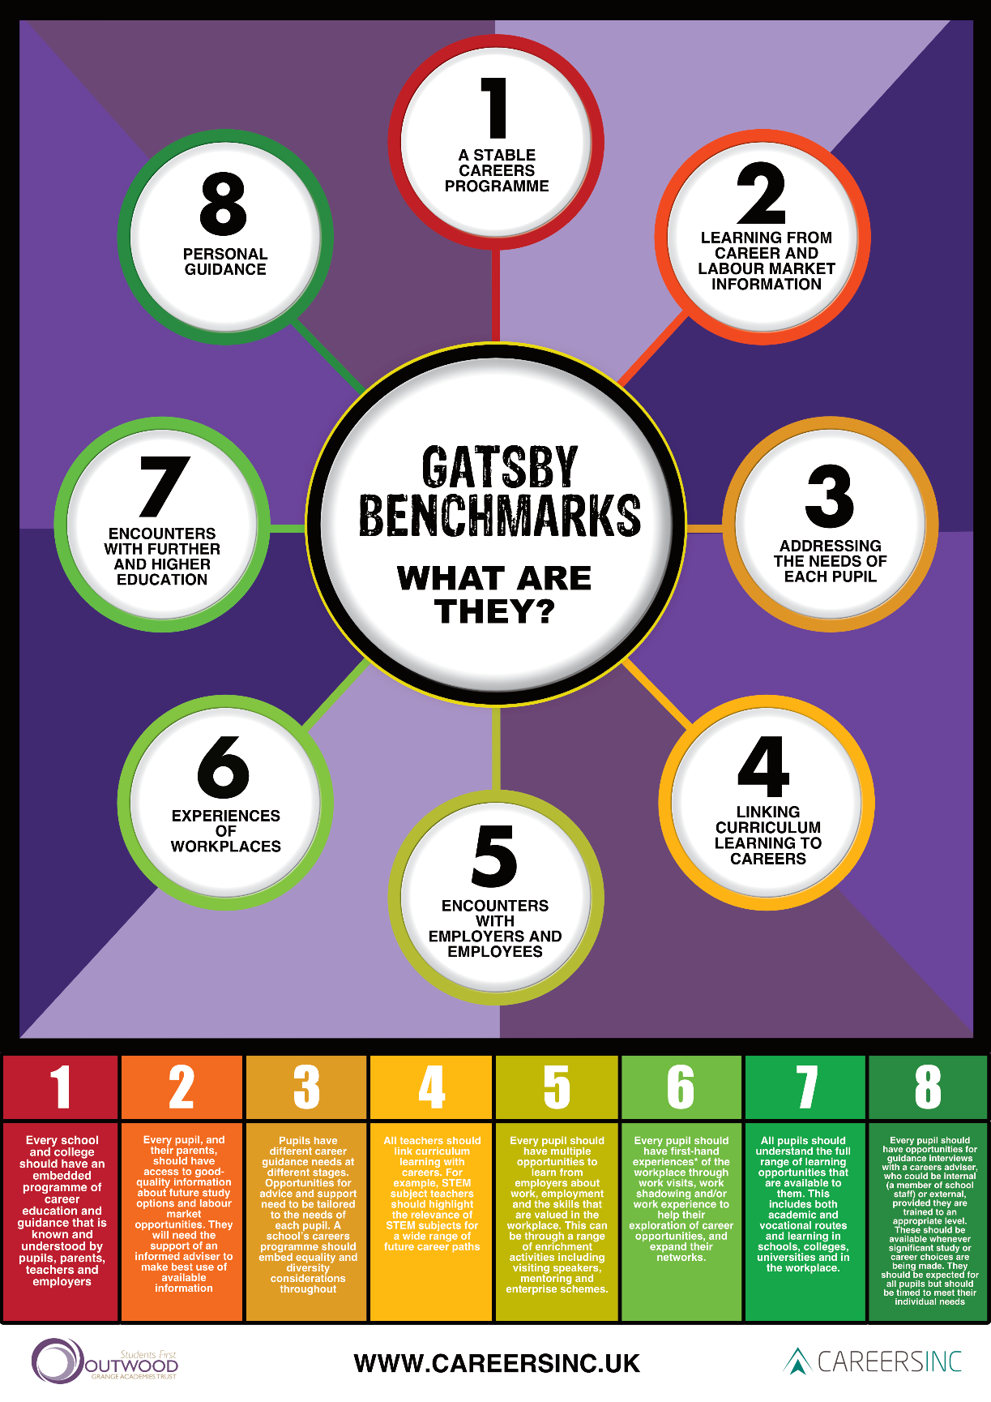

|  |  |  |  |
| --- | --- | --- | --- |
| **Policy Reviews by:** | Jenna Johnson | **Signature:**  J.Johnson | **Date:**  March 2025 |
| **Head Teacher:** | Christina Darkes | **Signature:**  C.Darkes | **Date:**  March 2025 |
| **Next Review Date:** | September 2025 | **Last Review Date:** | N/A |