

**Curriculum**

**and**

**Planning**

**Policy**

**Options Higford**

# Introduction

This policy outlines Options Autism’s aims to ensure effective & consistent practice throughout the school that maximises learning opportunities and achievement through the highest quality teaching for every student at Higford.

# Aims of our Practice

At Higford our promise underpins all that we do. We want our students to be:

# Education, Health and Care Plans- “The Golden Thread”

Each student has an Education. Health and Care Plan (EHCP) which sets out long term outcomes within five areas:

* Communication and Interaction
* Cognition and Learning
* Social, Emotional and Mental Health
* Sensory and Physical
* Independence- Although only statutory from Year 9, all students have an independence target which supports them in Preparing for Adulthood.

These EHCP outcomes form the golden thread of each student’s individual curriculum provision, lesson planning and assessment, and impact on every aspect of each students’ education.

Yearly targets are written from the EHCP outcomes and are directly linked into medium term and weekly planning as well as formative and summative assessment tools. These targets are written jointly with the onsite clinical team.

Each students’ curriculum and assessment links back to their EHCP outcomes and yearly education targets. The process that this takes is shown below.

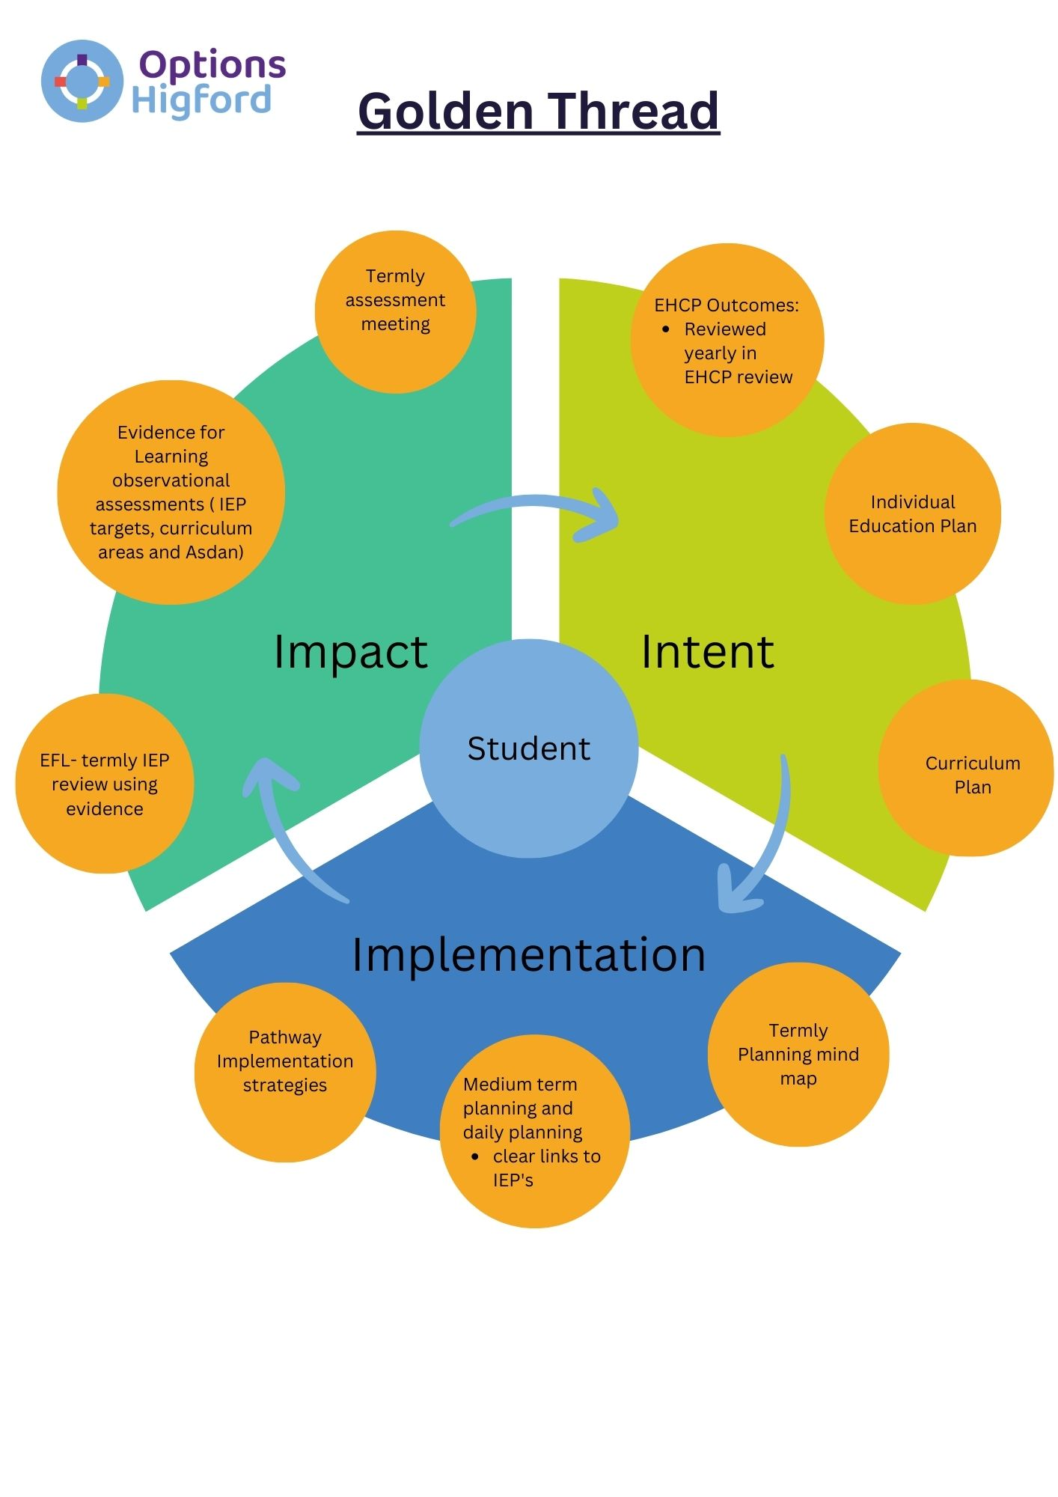

# Curriculum Content

From Key Stage One, students at Higford follow either the Engagement or the Application pathway. The cohorts for each pathway have a unique profile, as described in the pathway overview. Students are able to move between pathways if their needs change over time, and this is monitored as part of our continuous assessment.

Post-16 students follow the Post-16 pathway, which is tailored to meet their individual needs and prepare them for adulthood, further education, or the world of work. This pathway builds upon prior learning and continues to reflect the personalised and flexible approach that is central to our curriculum model.

# Pathway Overview- Engagement Pathway

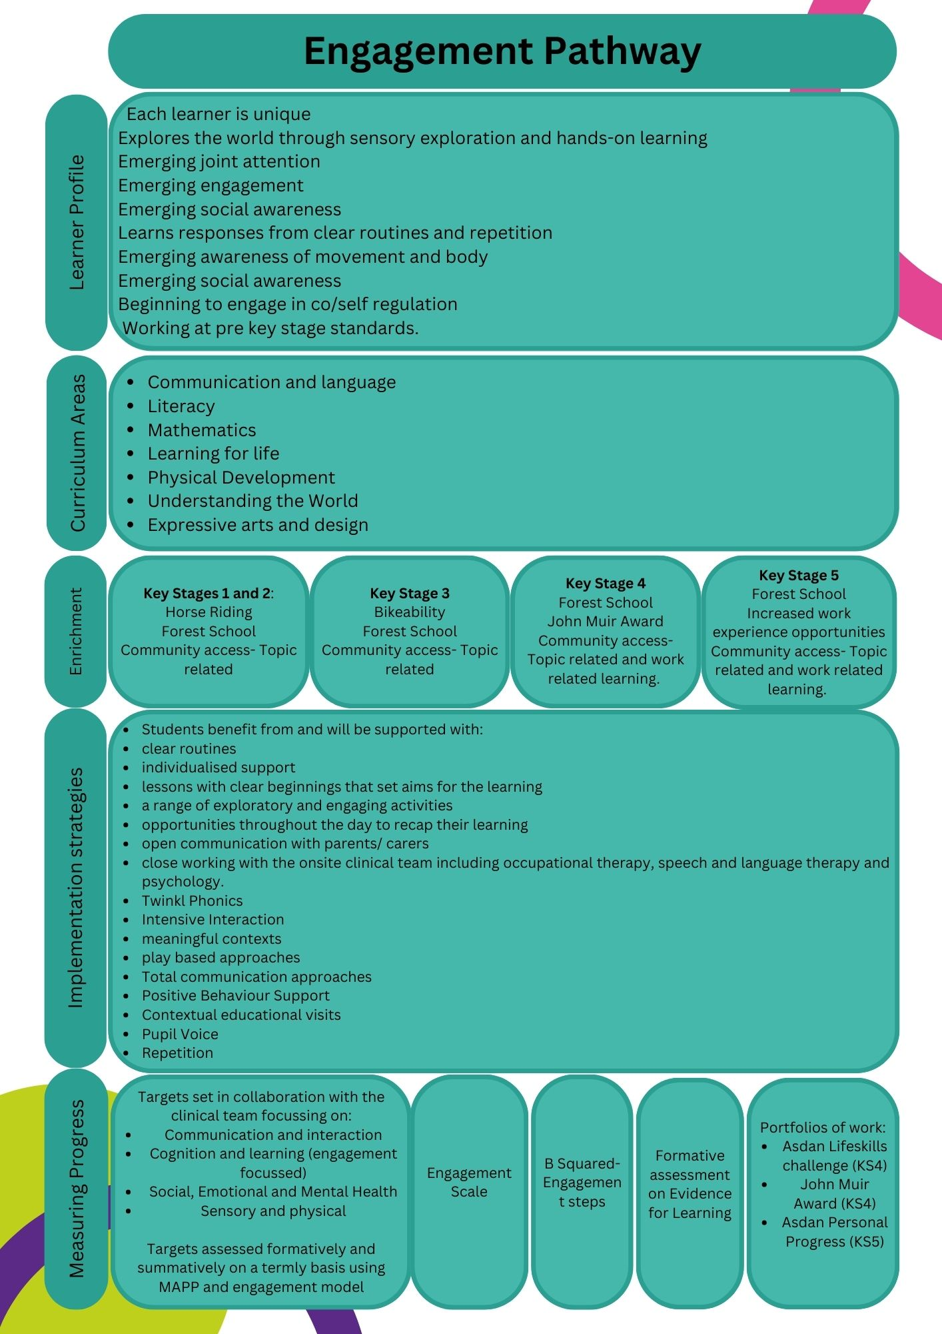

# Pathway Overview- Application Pathway

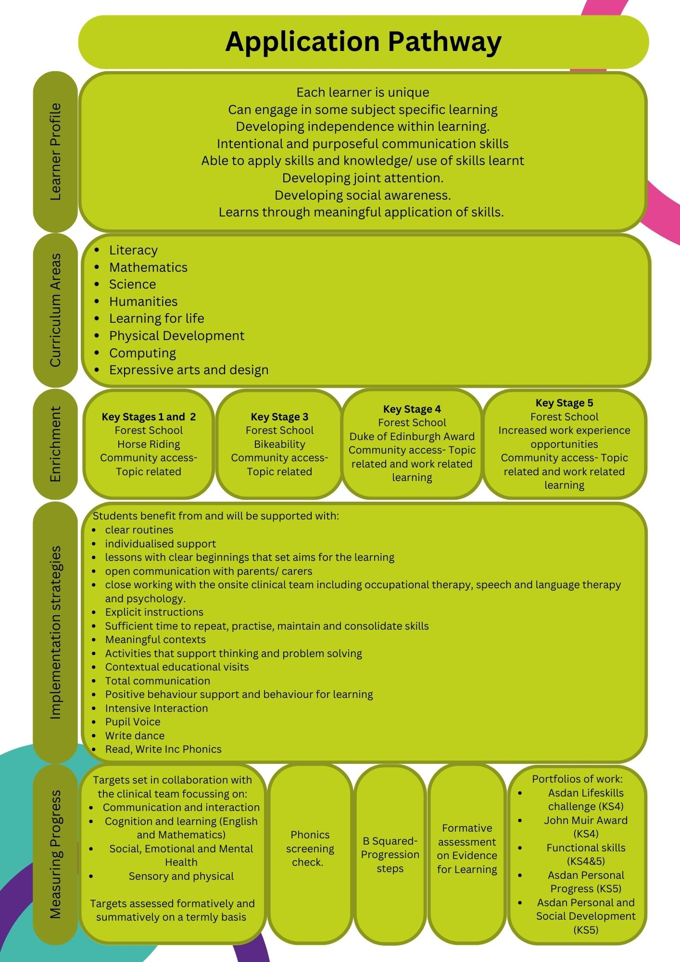

# Curriculum areas

**Curriculum Design and Implementation at Options Higford**

At Options Higford, we deliver a fully personalised curriculum across **three distinct learning pathways**—**Engagement**, **Application**, and **Post-16**—designed to support a wide range of special educational needs. Our curriculum is underpinned by a **three-year thematic cycle** that provides a broad, balanced and meaningful range of experiences across all subject areas and developmental domains.

This structure ensures vertical progression across key developmental areas and horizontal breadth across subjects and themes, allowing all learners to access content through a lens that is appropriate to their stage and style of learning.

**Engagement Model**

The Engagement Model is designed for learners working at pre-subject specific levels. Learning is holistic, sensory-rich, and focuses on developing foundational skills through highly personalised, interest-led, and exploratory approaches.

**Core Developmental Domains:**

* **Communication and Interaction**
* **Thinking Skills**
* **Social, Emotional and Mental Wellbeing**
* **Independence**
* **Creativity**
* **Sensory and Physical Development**

**Key Resources and Strategies:**

* *Communication*: Colourful Semantics, Word Aware, British Sign Language, Visual Schedules, AAC, Communication and Interaction IEP targets
* *Literacy & Language*: Twinkl Phonics, Rhino Readers, Write Dance, Interactive Storytelling, Playdough Disco, Sensory Stories, Handwriting Curriculum
* *Thinking & Cognition*: Problem Solving Tasks, Executive Functioning, Cognition and Learning IEP targets
* *Wellbeing & SEMH*: SEMH IEP targets, Emotional Regulation, Social Skills
* *Independence*: Decision Making, Cooking, Shopping, Snack Shack, Independence IEP targets
* *Creative Development*: Art, Charanga Music, Drama, Sensory Stories
* *Physical & Sensory*: PE, TACPAC, Danny Go, Cosmic Yoga, Sensory Circuits, OT Input, Sensory Bins, Sensory and Physical IEP targets

**Application Model**

The Application Model is for students working at subject-specific levels who can access a structured and thematic curriculum across key areas. Learners apply knowledge and develop skills through hands-on, functional, and relevant learning opportunities.

**Subject Areas Covered:**

* **English** (Literacy, Reading & Comprehension, Writing, Communication)
* **STEM** (Maths, Science, Technology)
* **Physical Development**
* **Understanding the World**
* **Outdoor Learning**
* **Creative Arts**
* **Learning for Life**

**Tools and Approaches:**

* *English & Communication*: Twinkl Phonics, Rhino Readers, Accelerated Reader (MyOn), Write Dance, Colourful Semantics, Clicker, Word Aware, Playdough Disco, Grid Box, Handwriting Curriculum, Educity, Communication & Interaction IEPs
* *Maths*: White Rose Maths, PlanIt Maths, Educity, Number of the Week, Functional Maths, Problem Solving
* *Science & Tech*: Practical enquiry, Coding and Robotics
* *Cognition & Learning*: Problem Solving Tasks, Executive Functioning, Cognition and Learning IEPs
* *Creativity*: Art, Charanga Music, Drama
* *Physical Development*: PE, TACPAC, Danny Go, Yoga, Sensory Circuits, OT Input, Sensory and Physical IEPs
* *Outdoor Learning*: Forest School, Horticulture, Outdoor Play
* *Life Skills*: Cooking, Shopping, Snack Shack, Learning for Life, Community-Based Instruction
* *Humanities*: History, Geography, RE
* *Wellbeing*: SEMH IEPs, Emotional Regulation, Social Skills Groups

**Post-16 Model**

The Post-16 curriculum focuses on **Preparation for Adulthood**, incorporating functional academics, personal development, and vocational learning. The emphasis is on equipping learners with the tools to lead fulfilling, independent lives.

**Key Focus Areas:**

* **Functional English and Communication**
* **Functional Maths and Problem Solving**
* **Employment and Vocational Learning**
* **Independent Living Skills**
* **Health and Wellbeing**
* **Community Inclusion**
* **Learning for Life**

**Provision Includes:**

* *Functional Skills*: English, Maths, Communication, Problem Solving through Entry Level Functional Skills and AQA Unit Awards
* *Life Skills*: Cooking, Shopping, Snack Shack, Money Management, Using Technology in the Home and Community, Daily Living Skills
* *Employment Prep*: Work Experience, ASDAN PSD (Managing Money, Community Action, Preparation for Work), Self-Advocacy Training, Soft Skills Training
* *Health & Wellbeing*: ASDAN PSD (Healthy Living, Leisure Time, Personal Safety), Mental Health Support, Emotional Regulation, SEMH IEPs
* *Community Access*: Community Inclusion, Offsite Visits, Horticulture, Forest School, Environmental Awareness, Social Integration
* *Communication*: AAC, Social Stories, Communication & Interaction IEPs
* *Physical Development*: Yoga, Danny Go, Sensory Circuits, OT Input, Physical Activity Programmes

**Three-Year Theme Cycle**

Each model follows a **shared three-year thematic cycle**, ensuring a consistent, whole-school focus across subjects while allowing for differentiated delivery depending on pathway. This enables students to revisit key concepts through varied lenses, deepening their understanding and widening their engagement.

Themes are broad and inclusive, incorporating seasonal, scientific, cultural, and real-world topics to inspire curiosity, relevance and connection to the world. Topics are explored through:

* Creative projects
* Literacy links
* Sensory exploration
* Scientific enquiry
* Community experiences

This approach allows for progression in knowledge and skills while remaining adaptable to individual needs and interests.

**Enrichment activities**

* Community access

All students at Options Higford have regular access to offsite and community access in the most appropriate way for them. Our aim is for all students to be able to live the most independent lives possible where they can access a range of facilities and be able to make contributions to their community.

When students start at Higford these community visits are built upon gradually, in line with individual needs. Although not prescriptive these visits usually start as walks onsite and then the local area before short car rides in the local area. These extend over a relevant time frame and appropriateness for each student to accessing a range of facilities including local parks, shops, including supermarkets, clothes shops and post offices as well as leisure facilities, swimming pools, public transport and cafes and restaurants.

Community access supports the students in developing independence e.g. following a shopping list when in a supermarket, using public transport, understanding and using money as well as developing the ability to communicate with members of the public and regulate their emotions, both through co and self-regulation, away from their secure environments.

* Horse riding

Our Key Stage one and two students have the option to access horse riding offsite in order to develop their confidence in their community, interaction with others and also their gross motor skills.

* Bikeability

In Key stage 3 students have the opportunity to access a bikeability course to develop their gross motor skills and understanding of safety rules.

* Forest School

All students at Options Higford have access to weekly Forest School sessions run by Level 3 Forest School leaders. These sessions take place onsite at one of our two Forest School sites throughout the year.

Forest School sessions support students in developing an appreciation and awareness of the natural world, managing risk in a safe, appropriate way whilst also developing tolerance of and shared working with peers.

* Horticulture

Students also take part in weekly horticulture sessions where they take part in growing and caring for a range of plants. There is a horticulture pod onsite that acts as a greenhouse as well as a horticulture garden with raised beds. Fore the KS4 and KS5 students this planting also acts as part of their work-related learning.

* John Muir Award and Duke of Edinburgh Award

In KS4, students on the engagement pathway work towards the John Muir Award in order to connect with, enjoy and care for wild places. This award allows them to contribute to their community in a purposeful way.

The KS4 students on the application pathway work towards their bronze duke of Edinburgh award in order to develop new skills, contribute to society and also grow in confidence.

# Implementation (Planning practise)

A yearly curriculum overview is written by the subject leads that sets out the breadth of the curriculum over an academic year. This information is used to inform termly planning meetings with all teachers where ideas are shared. Teachers will then put together a class medium term plan using the information from the individual termly planning overviews. This sets out the activities that will take place each week in each curriculum area and includes learning objectives, activities, links to ASDAN modules and individual targets.

Weekly plans are written which set out the learning objectives, activities, resources needed and specific assessment tools to be used each day. These documents are accessible to all class staff to encourage sharing of targets, responsibilities and assessment input.

Medium Term Plans are collected and audited by the subject leads at the beginning of each half term.