Curriculum

and

Planning

Policy

Options Higford

Introduction

This policy outlines Options Autism’s aims to ensure effective & consistent practice throughout the school that maximises learning opportunities and achievement through the highest quality teaching for every student at Higford.

Aims of our Practice
At Higford our promise underpins all that we do. We want our students to be:
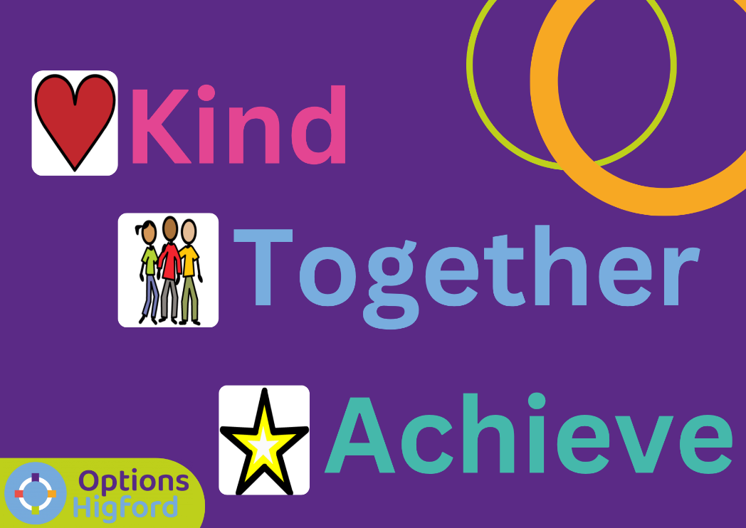

Education, Health and Care Plans- “The Golden Thread”

Each student has an Education. Health and Care Plan (EHCP) which sets out long term outcomes within five areas:
- Communication and Interaction
- Cognition and Learning
- Social, Emotional and Mental Health
- Sensory and Physical
- Independence- Although only statutory from Year 9, all students have an independence target which supports them in Preparing for Adulthood.

These EHCP outcomes form the golden thread of each student’s individual curriculum provision, lesson planning and assessment, and impact on every aspect of each students’ education.

Yearly targets are written from the EHCP outcomes and are directly linked into medium term and daily planning as well as formative and summative assessment tools. These targets are written jointly with the onsite clinical team.

Each students’ curriculum and assessment links back to their EHCP outcomes and yearly education targets. The process that this takes is shown below.

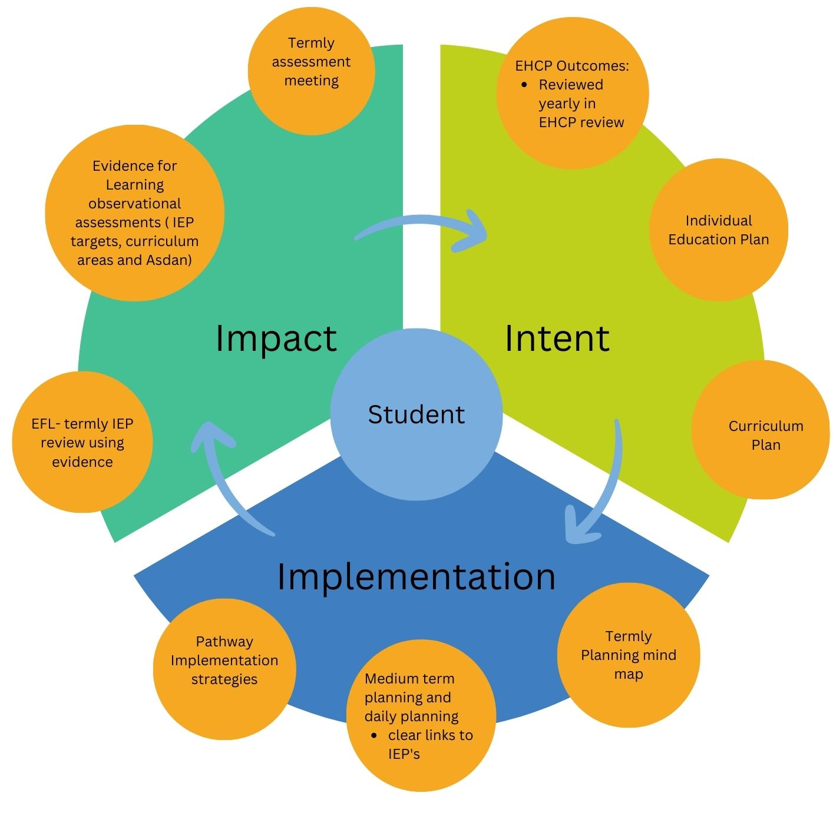

Curriculum Content

Key Stage one students at Higford follow the Early Years Foundation Stage to allow them time to develop the skills needed to engage in purposeful learning. The emphasis on Key Stage one is to develop students so that they are ready to learn, are developing their internal curiosity and have trusting relationships with supporting adults.
From Key Stage two the students at Higford follow either the engagement or the application pathway. The cohorts for each pathway have a unique profile as described on the pathway overview. Students are able to move between pathways if their needs change over time and this will be monitored as part of our continuous assessment.

Pathway Overview- Engagement Pathway

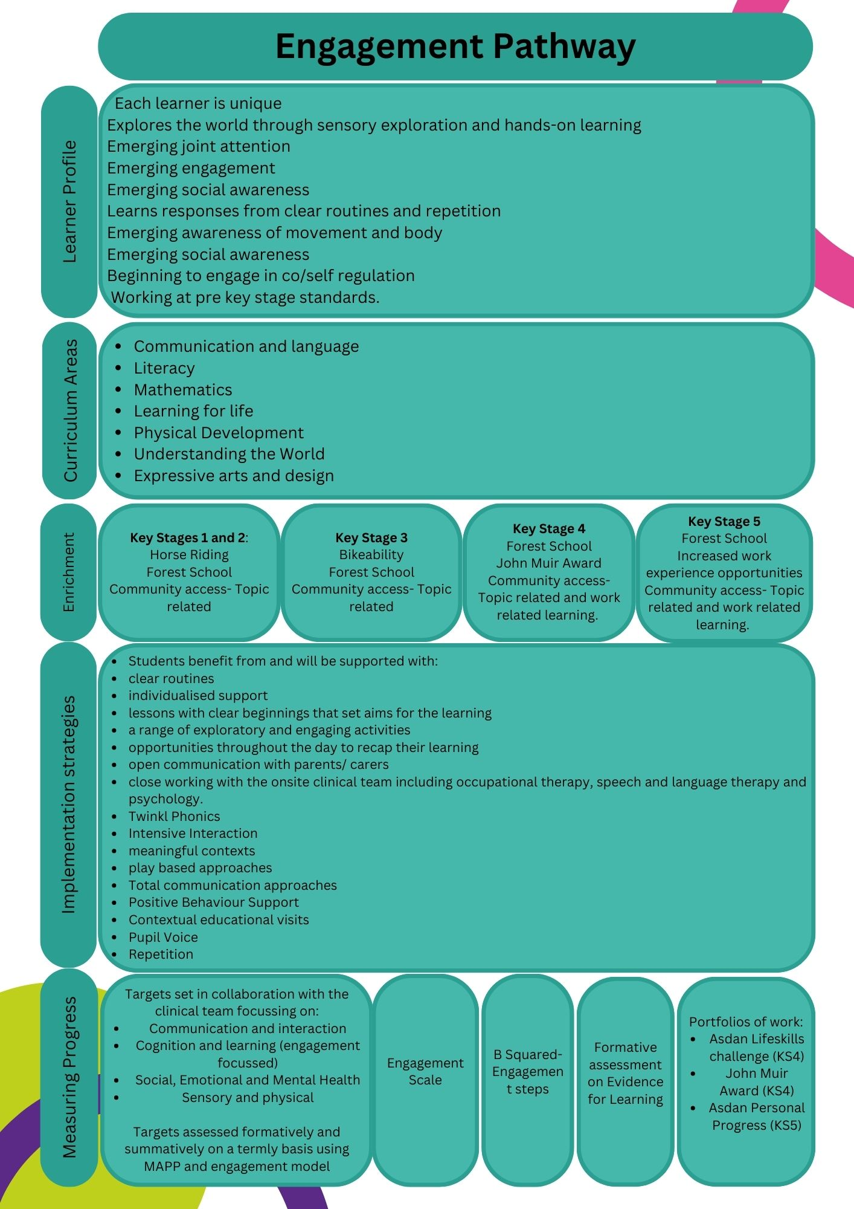

Pathway Overview- Application Pathway

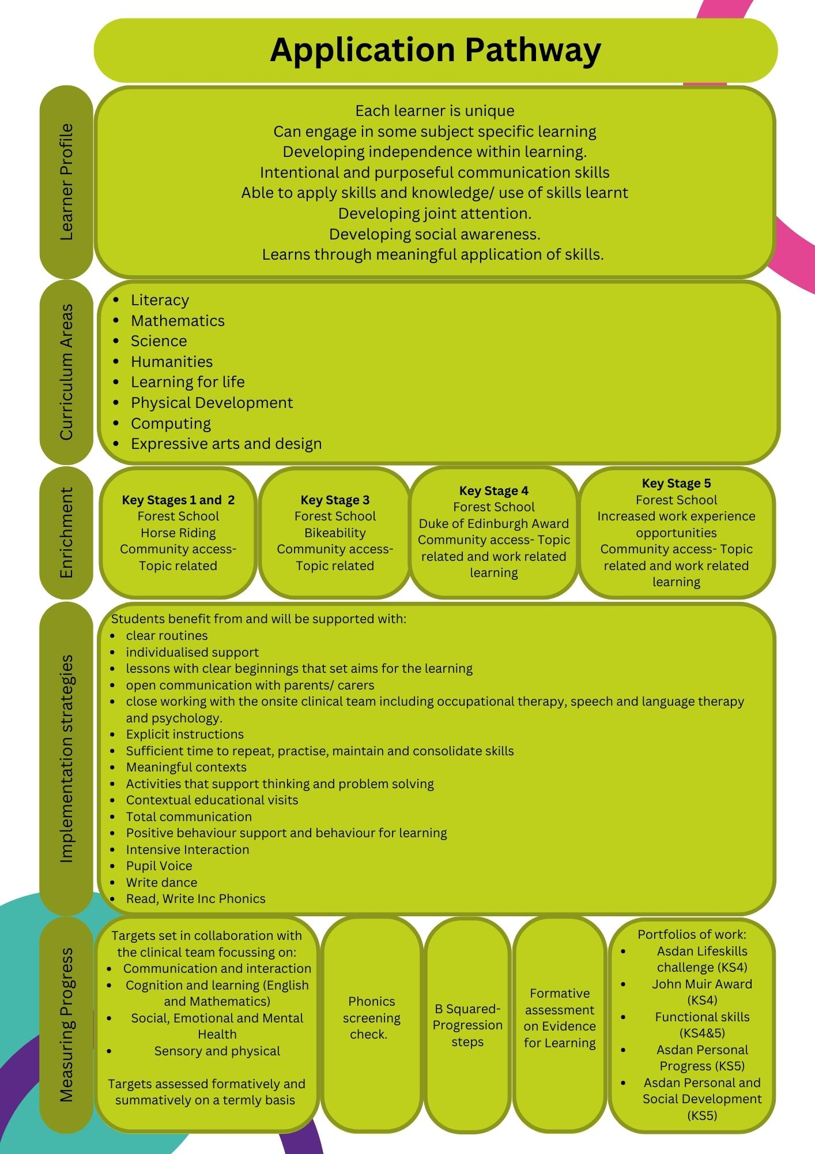

Curriculum areas

Literacy

Literacy is taught through standalone and thematic literacy lessons. Literacy lessons are planned, primarily in a thematic way, to develop communication skills, including reading and writing where appropriate as well as develop a passion for reading and books. The content of the books covered is wide ranging and includes a range of fiction, non-fiction and poetry texts over the year. The texts used in lessons, and available in the library, include a wide range of characters including those of different ethnicities, disabilities, genders, religions and sexualities. There are books available that represent all of our students in the school. These texts also challenge typical stereotypes, discuss emotions and promote the British values of rule of law, democracy, individual liberty, mutual respect and tolerance of other faiths and beliefs.

Separate to literacy lessons, all students also take part in daily phonics and reading sessions. The students are all at different Stages of their phonic awareness and this is recorded on a whole school document. Each class has a reading champion to support reading across all students. We initially ensure all students have developed the foundations of speaking and listening skills through the use of Twinkl Phonics phase 1. This Stage will support students in attuning with the sounds around them and readies them to begin developing oral blending and segmenting skills. Once students have developed these skills they work through the Read, Write, Inc programme of phonics. Some of our students then progress onto reading for pleasure. These students are supported by the reading champions who have received ‘Better Reading Support Partner’ training. There are a range of reading schemes available for our students who have moved through the phonics programme and these are suitable for all ages.

Communication and Language

One of the main aims for our students at Higford is to be able communicate their views. Therefore, communication is taught across all Key Stages in a functional and meaningful way. We aim to develop each student’s communication skills so that they can communicate their needs, wants, views and feelings in the most meaningful and appropriate way for them.

Opportunities to develop communication are embedded through all aspects of the students’ day. All students have a communication profile, written by the onsite Speech and Language Therapist, in liaison with the Key staff members and parents/ carers. This document is used to ensure that communication strategies are appropriate and relevant targets are set and followed.

Our students are supported by a range of communication strategies, as set out in their Communication Profile, which may include the use of visual support tools, high and low tech augmentative and alternative communication, photos/symbols/ object of reference, written support tools and Makaton.

Mathematics

Mathematics is taught as a standalone lesson for all students. The aim is to develop the mathematical skills and awareness of all students to benefit them, functionally, for lifelong independence where possible.

The areas covered in maths are set out in the yearly planning overview document to ensure the breadth of coverage across the academic year. The areas covered include:
- Number and place value
- Addition and subtraction
- Multiplication and division
- Handling data
- Shape
- Fractions
- Problem solving
- Position and direction
- Time
- Capacity and weight
- Money
- Length

Maths lessons are taught in hands on, practical sessions where possible and class-based learning is transferred to real life experiences where applicable. Sessions such as cooking are utilised to teach mathematical concepts such as capacity and weight. Offsite visits also support the development of knowledge of maths concepts including the use of money in real life contexts.

Learning for Life

The Higford Learning for Life curriculum covers PSHE, SRE, Independence and careers. Students access a curriculum that develops skills for lifelong independence. These skills are taught in discrete lessons as well as embedded throughout the whole school day within lessons and also through transitional times such as snack and lunchtime. This curriculum supports students in developing emotional awareness of self and others, develop and build on relationships with others as well as an understanding of their body and how to care for it. There are six ‘modules’ covered over the year including:
- Body awareness
- Hygiene- self and home
- Relationships
- Knowing yourself/ others
- Health
- Sex (only taught when relevant).

Cooking, mini-enterprise and community access are also covered throughout the year. The curriculum is taught to all students at an appropriate developmental level and all individual needs are considered. The statutory requirements from the Relationship and Sex Education and Health Education guidance (2020) are considered throughout and all lessons are taught in an inclusive way that is non-discriminatory against any protected characteristics.

Students’ Spiritual, Moral, Social and Cultural development is supported throughout the curriculum and through staff instilling appropriate values in all of their interactions and support of students.

To develop spiritual awareness students are supported to develop a sense of self and explore their own views and beliefs as well as respect others views. This may be through choice making, taking turns or listening to others.

At Options Higford we support students to develop their moral awareness through assisting them in understanding what is right or wrong and the consequences of their actions as they arise. We use a non-sanction-based approach to behaviour and this is followed by all staff as discussed in the Positive Behaviour Support Policy.

Social development is embedded in the whole daytime routine of all students. Each class has a shared registration and circle time each day as well as other opportunities throughout the day for development of social skills including shared lessons and meal times as well as assemblies, Forest School and play times. These shared activities support students in developing their fundamental British values of democracy, the rule of law, individual liberty and mutual respect and tolerance of others.

Physical Development

All of the students at Higford engage in a wide range of physical activity interspersed throughout their curriculum to aid regulation and support them in being ready to learn. This is supported by each students’ individual sensory motor profile where it is relevant. These physical activities are benefited by onsite facilities including trampoline, indoor physical education spaces and outdoor gym equipment, indoor and outdoor waterplay, play equipment and bikes and scooters. Options Higford also utilises its rural location and the students take part in regular walks in the local environment.

Formal PE sessions are focussed on a number of areas that develop gross motor skills in a variety of areas. These include:
- Sports- invasion games; net and field games; striking and fielding
- Athletics and basic movement
- Outdoor and adventurous activities
- Fitness
- Gymnastics and movement including dance and yoga
- Swimming and aquatic sports.

Expressive arts and design

Students’ creativity is supported throughout the curriculum within all subjects. Dance, drama, art and music are all planned for over the term and embedded within the thematic planning.

All lessons are made fun, hands on and incorporating a range of creative sensory resources where possible to support engagement in sessions. Students’ sensory profiles are considered when these sessions are planned.

Within the application pathway students also engage in design technology.

Science

Students within the application pathway access standalone science lessons as well as encouraging scientific thinking throughout other lessons. Through these lessons we promote an enquiry-based approach to learning with practical experiences.
The areas covered as part of science lessons includes:
- plants
- living things and their habitats
- animals (including humans)
- Everyday materials
- seasons
- forces and magnets
- light and sound
- electricity

Understanding the World

Within the engagement pathway students access topic-based learning opportunities which supports their holistic understanding of the world around them. To ensure the curriculum is broad, topics are planned on a three-year programme to ensure coverage across geography, history, science and religious studies themes.

Humanities

Within the application pathway students are taught discrete humanities lessons which cover geography, history and science. They access a topic-based curriculum with a three-year programme which incorporates topics based on the humanities subjects, including religious studies, to allow for in depth exploration of these areas.

Religious studies and culture.

Religious studies are embedded into the other curriculum areas as opposed to being standalone sessions on the timetable. Religious studies are also sometimes covered through focus days over the year that arise as part of the calendar e.g. religious festivals. At Options Higford we also ensure all students’ religious views are supported and celebrate these across school to support all students mutual respect and tolerance of other faiths.

Students awareness of their own and others’ cultures are supported through all aspects of the curriculum. At Options Higford we are proud of our multicultural community and ensure all are treated with respect. We ensure all students feel included, regardless of their cultural background and ensure that learning resources represent all students and cultures. Cultural events are celebrated as a school through events run over the year.

Computing

Computing is taught discretely to students working within the application pathway. The areas taught are:
- Knowing the computer
- Technology in the world
- Digital content
- Photography and editing
- Computer science and programming
- E-safety.

Enrichment activities

- Community access

All students at Options Higford have regular access to offsite and community access in the most appropriate way for them. Our aim is for all students to be able to live the most independent lives possible where they can access a range of facilities and be able to make contributions to their community.

When students start at Higford these community visits are built upon gradually, in line with individual needs. Although not prescriptive these visits usually start as walks onsite and then the local area before short car rides in the local area. These extend over a relevant time frame and appropriateness for each student to accessing a range of facilities including local parks, shops, including supermarkets, clothes shops and post offices as well as leisure facilities, swimming pools, public transport and cafes and restaurants.

Community access supports the students in developing independence e.g. following a shopping list when in a supermarket, using public transport, understanding and using money as well as developing the ability to communicate with members of the public and regulate their emotions, both through co and self-regulation, away from their secure environments.

- Horse riding

Our Key Stage one and two students have the option to access horse riding offsite in order to develop their confidence in their community, interaction with others and also their gross motor skills.

- Bikeability

In Key stage 3 students have the opportunity to access a bikeability course to develop their gross motor skills and understanding of safety rules.

- Forest School

All students at Options Higford have access to weekly Forest School sessions run by Level 3 Forest School leaders. These sessions take place onsite at one of our two Forest School sites throughout the year.

Forest School sessions support students in developing an appreciation and awareness of the natural world, managing risk in a safe, appropriate way whilst also developing tolerance of and shared working with peers.

- Horticulture

Students also take part in weekly horticulture sessions where they take part in growing and caring for a range of plants. There is a horticulture pod onsite that acts as a greenhouse as well as a horticulture garden with raised beds. Fore the KS4 and KS5 students this planting also acts as part of their work-related learning.

- John Muir Award and Duke of Edinburgh Award

In KS4, students on the engagement pathway work towards the John Muir Award in order to connect with, enjoy and care for wild places. This award allows them to contribute to their community in a purposeful way.
The KS4 students on the application pathway work towards their bronze duke of Edinburgh award in order to develop new skills, contribute to society and also grow in confidence.

Implementation (Planning practise)

A yearly curriculum overview is written by the subject leads that sets out the breadth of the curriculum over an academic year. This information is used to inform termly planning meetings with all teachers where ideas are shared. Teachers will then put together a class medium term plan using the information from the individual termly planning overviews. This sets out the activities that will take place each week in each curriculum area and includes learning objectives, activities, links to ASDAN modules and individual targets.

Daily plans are written which set out the learning objectives, activities, resources needed and specific assessment tools to be used each day. These documents are accessible to all class staff to encourage sharing of targets, responsibilities and assessment input.

Medium Term Plans are collected and audited by the subject leads at the beginning of each half term.

