‘Golden Thread’

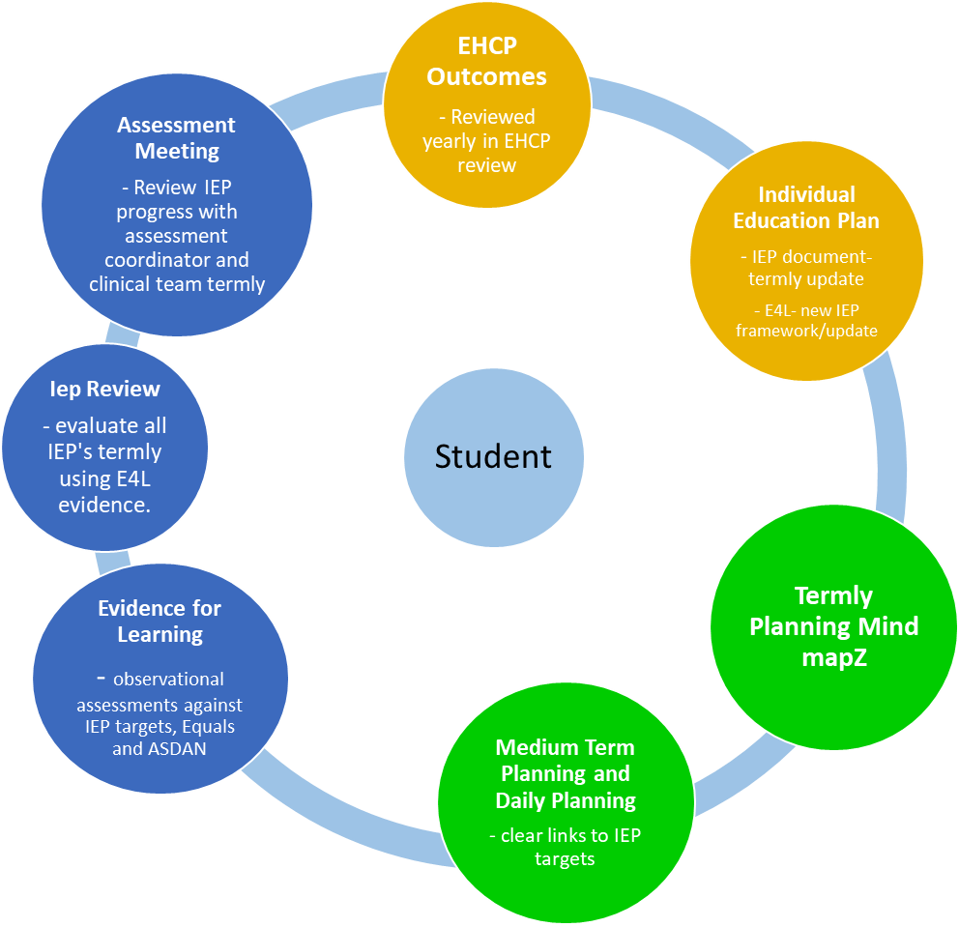

Impact

Intent

Implementation